Unit Rate and Proportion

1. It costs $54 to buy 18 cartons of milk. What is the cost of one carton?
2. Jack’s dad drove 240 miles in 4 hours. What was the speed in miles per hour?
3. Nancy can buy 228 tickets for $12. How much is the price for each ticket?
4. You score 84 points in 6 games. How much do you score per game?
5. A pump moves 42 gallons in 7 min. Find the unit rate.
6. Shelly can type 56 words in 8 minutes. How much time will she take to type 224 words?
7. Shelly can type 598 words in 13 minutes. What is her word per minute rate?
8. Monica needs soup. The store has special- 5 cans for $10.50 and 1 can for $2.40. Which is better deal? How much will it cost if she buys: a) 3 cans b) 15 cans?
9. 4 gallons of milk cost $16. How much gallon of milk can be bought for $80?
10. Eve plays basketball. She makes 4 free throws for every 3 free throws that she misses. If she missed 24 free throws at her last practice, how many free throws did she make?
11. Alexander is planning to travel from Hershey, Pennsylvania, to Durango, Colorado, during Winter Break for a ski vacation. The trip, almost all of it on the Interstate, will be 1,140 miles one-way. If he averages 60 miles per hour on the trip, about how long will it take him to get there?
12. If a pine tree grows 4 inches per year, how long will it take for the tree to reach a height of 32 feet?
13. A company is hosting a fundraising dinner and selling tickets to attend. The table below shows the total amount raised in relation to the number of tickets sold.

|  |  |  |  |  |  |
| --- | --- | --- | --- | --- | --- |
| **Tickets Sold** | 2 | 3 | 4 | 5 | 6 |
| **Total Raised** | $48.00 | $72.00 | $96.00 | $120.00 | $144.00 |

What is the rate of change for the information in the table?

|  |  |  |  |
| --- | --- | --- | --- |
|  |  | A. | $24.00 per ticket |
|  |  | B. | $36.00 per ticket |
|  |  | C. | $48.00 per ticket |

14. Fill in the blanks.

|  |  |  |  |  |  |
| --- | --- | --- | --- | --- | --- |
| |  |  | | --- | --- | | 1. | 288 pages in 6 days  =  ______   days for 1152 pages | | |  |  | | --- | --- | | 2. | 110 meters in 2 seconds  =  ______   meters in 5 seconds | |
| |  |  | | --- | --- | | 3. | 120 seats in 4 rows  =  ______   seats in 12 rows | | |  |  | | --- | --- | | 4. | 16 calls in 8 hours  =  ______   calls in 9 hours | |
| |  |  | | --- | --- | | 5. | 1,035 miles in 3 hours  =  ______   miles in 7 hours | | |  |  | | --- | --- | | 6. | 1,540 miles in 11 hours  =  ______   miles in 1 hour | |

15. Circle the better buy. Explain why it is the better buy.

|  |  |  |  |  |  |  |  |  |  |  |  |
| --- | --- | --- | --- | --- | --- | --- | --- | --- | --- | --- | --- |
| |  |  |  |  |  | | --- | --- | --- | --- | --- | | 1. | |  |  |  | | --- | --- | --- | | $112 for 8 calendars |  | $108 for 6 calendars | | | |  |  |  |  |  | | --- | --- | --- | --- | --- | | 2. | |  |  |  | | --- | --- | --- | | 16 pens for $3.04 |  | 10 pens for $1.60 | | |
| |  |  |  |  |  | | --- | --- | --- | --- | --- | | 3. | |  |  |  | | --- | --- | --- | | 15 DVDs for $105 |  | 31 DVDs for $279 | | | |  |  |  |  |  | | --- | --- | --- | --- | --- | | 4. | |  |  |  | | --- | --- | --- | | 2 liters for $0.96 |  | 16 liters for $7.68 | | |
| |  |  |  |  |  | | --- | --- | --- | --- | --- | | 5. | |  |  |  | | --- | --- | --- | | $59.85 for 3 pounds |  | $99.90 for 6 pounds | | | |  |  |  |  |  | | --- | --- | --- | --- | --- | | 6. | |  |  |  | | --- | --- | --- | | $5.76 for 24 pens |  | $5.40 for 20 pens | | |
|  |  |

16. One yard of ribbon costs $0.49 and 3 yards of ribbon costs $1.49. Which has the lower unit price?

1. 2/3 of a pound of walnuts costs $2.50. Half a pound costs $2.25. Which is a better deal?
2. Bria travels by plane often for work. She graphed the distance of each trip and the cost of the airfare.

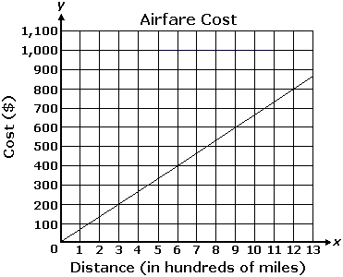

Which of the following describes the rate at which the cost of the airfare changed?

|  |  |  |  |  |  |
| --- | --- | --- | --- | --- | --- |
|  | |  | A. | It increased $2 for every 3-mile increase in distance. | |
|  | |  | B. | It increased $2 for every 300-mile increase in distance. | | |
|  |  | | C. | It increased $2 for every 1-mile increase in distance. |

D. It increased $200 for every 300-mile increase in distance.

1. An online website rates restaurants that serve hamburgers on a scale from 0 to 10. The graph below shows the ratings of all the restaurants on the website and the costs of hamburgers at those restaurants.

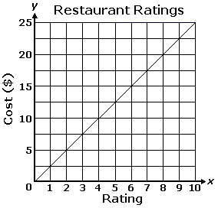

Which of the following describes the rate at which the cost of a hamburger changed?

|  |  |  |  |
| --- | --- | --- | --- |
|  |  | A. | It increased $2.50 for every increase of 1 in rating. |

|  |  |  |  |
| --- | --- | --- | --- |
|  |  | B. | It increased $5.00 for every increase of 1 in rating. |

|  |  |  |  |
| --- | --- | --- | --- |
|  |  | C. | It increased $1.00 for every increase of 5 in rating. |

|  |  |  |  |
| --- | --- | --- | --- |
|  |  | D. | It increased $1.00 for every increase of 2.5 in rating. |
|  |  |  |  |

